**INTRODUCTION**

**TO**

**C PROGRAMMING**

SARTHAK SANAY

**(1) AIM:-**

To write a simple program in C which displays "Hello, World!" on the screen

**CODE:-**

**#include <stdio.h>**

**int main()**

**{**

**printf("Hello, World!");**

**return 0;**

**}**

**OUTPUT SCREEN:-**

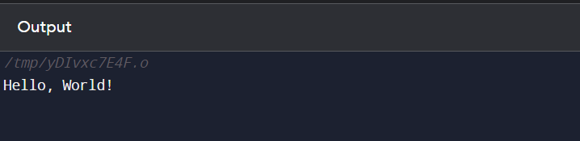

**(2) AIM:-**

To write a program in C to take the name of the user as input and then display a greeting message.

**CODE:-**

**#include <stdio.h>**

**int main()**

**{**

**// declaring a variable with space of 100 characters, to store the name entered by the user**

**char name[100];**

**printf("Enter your name: ");**

**scanf("%s", &name); // storing the input from the user**

**printf("Hello %s! Have a great day ahead!", name); // printing the greeting message**

**return 0;**

**}**

**OUTPUT SCREEN:-**

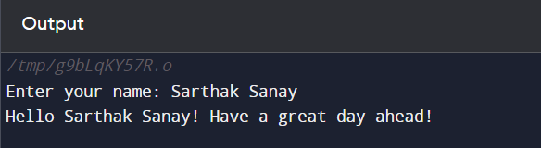

**(3) AIM:-**

To explore different data types in C (int, float, char) and write programs to manipulate them.

**CODE:-**

**// Program in C to explore different data types in C (int, float, char) and write programs to manipulate them.**

**#include <stdio.h>**

**int main()**

**{**

**// Exploring and performing operations on the Integer (int) data type.**

**int i1 = 400, i2= 100, iRes;**

**printf("Performing arithmetical operations on the Integer (int) data type.\n");**

**iRes = i1+i2; // addition**

**printf("%d + %d = %d\n", i1, i2, iRes);**

**iRes = i1-i2; // subtraction**

**printf("%d - %d = %d\n", i1, i2, iRes);**

**iRes = i1*i2; // multiplication**

**printf("%d x %d = %d\n", i1, i2, iRes);**

**iRes = i1/i2; // division**

**printf("%d / %d = %d\n\n", i1, i2, iRes);**

**// Exploring and performing operations on the Float data type.**

**float f1 = 100.45, f2 = 30.2, fRes;**

**printf("Performing arithmetic operations on the Float data type.\n");**

**fRes = f1+f2; // addition**

**printf("%f + %f = %f\n", f1, f2, fRes);**

**fRes = f1-f2; // subtraction**

**printf("%f - %f = %f\n", f1, f2, fRes);**

**fRes = f1*f2; // multiplication**

**printf("%f x %f = %f\n", f1, f2, fRes);**

**fRes = f1/f2; // division**

**printf("%f / %f = %f\n\n", f1, f2, fRes);**

**// Manipulating character (char) data type**

**char c1='A', c2='B';**

**printf("Concatenating two characters: %c%c\n", c1, c2);**

**// Returning ASCII values designated to that character**

**printf("ASCII value of %c is: %d\n", c1, c1);**

**printf("ASCII value of %c is: %d", c2, c2);**

**return 0;**

**}**

**OUTPUT SCREEN:-**

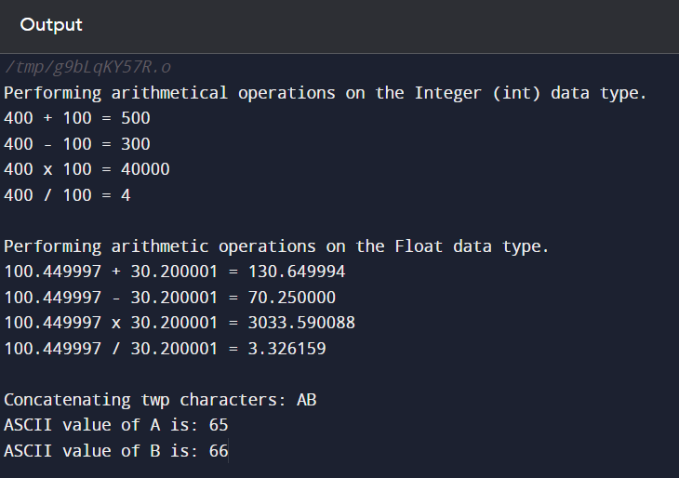

**(4) AIM:-**

To write a program in C that calculates the area of a rectangle and a circle based on user input.

**CODE:-**

**#include <stdio.h>**

**int main()**

**{**

**int c;**

**printf("Enter 1 to find area of Rectangle\nEnter 2 to find area of Circle\n");**

**scanf("%d", &c);**

**if (c==1)**

**{**

**printf("Calculating the area of Rectangle\n");**

**int l,b;**

**printf("Enter length: ");**

**scanf("%d", &l);**

**printf("Enter breadth: ");**

**scanf("%d", &b);**

**int areaRect = l*b;**

**printf("Area of the Rectangle is %d", areaRect);**

**}**

**else if (c==2)**

**{**

**printf("Calculating the area of Circle\n");**

**int r;**

**printf("Enter radius: ");**

**scanf("%d", &r);**

**float areaCircle = (3.14*r*r);**

**printf("Area of the Circle is %f", areaCircle);**

**}**

**else**

**printf("Enter the correct number.");**

**return 0;**

**}**

**OUTPUT SCREEN:-**

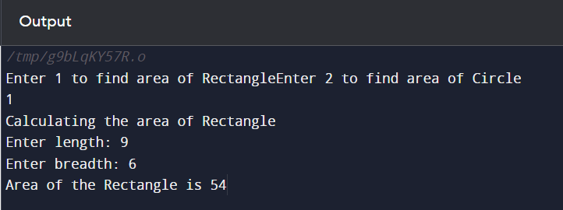

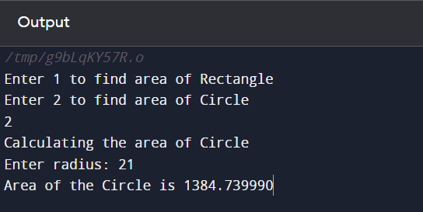

**(5) AIM:-**

To write a simple calculator program in C that performs addition, subtraction, multiplication and division based on user choice.

**CODE:-**

**#include <stdio.h>**

**int main()**

**{**

**int ch, a, b;**

**printf("Simple Calculator Program\nEnter 1 for addition, 2 for subtraction, 3 for multiplication, or 4 for division : ");**

**scanf("%d", &ch);**

**printf("Enter 1st number: ");**

**scanf("%d", &a);**

**printf("Enter 2nd number: ");**

**scanf("%d", &b);**

**if (ch==1)**

**printf("Sum of %d and %d is %d \n\n", a, b, a+b);**

**else if (ch==2)**

**printf("Difference between %d and %d is %d \n\n", a, b, a-b);**

**else if (ch==3)**

**printf("Product of %d and %d is %d \n\n", a, b, a*b);**

**else if (ch==4)**

**printf("Quotient of %d and %d is %d \n\n", a, b, a/b);**

**else**

**printf("Enter correct number for choice.");**

**return 0;**

**}**

**OUTPUT SCREEN:-**

